Balam Indira Priyadarsini

**Bridge Course Assignment-Day 1**

**Section -1:Data**

**1. Input and output practice**

**Problem statement:** write a program that takes your name and age as input and prints a greeting

like: “Hello John, you are 20 years old.”

**Algorithm :**

1.Start the program

2.Ask the user to enter their **name**

3.Ask the user to enter their **age**

4.Store both inputs

5.Print the message: “Hello <name>, you are <age> years old.”

6.End the program

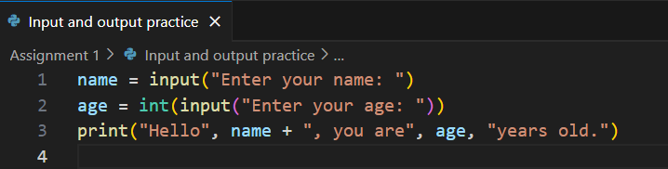**Code:**

**Output:**

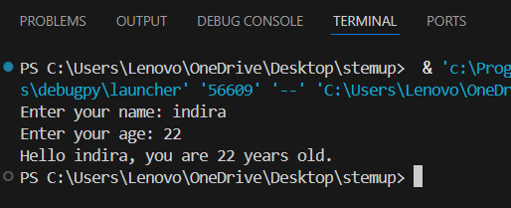

**Test Cases:**

|  |  |  |
| --- | --- | --- |
| **Input Name** | **Input Age** | **Expected Output** |
| Priya | 25 | Hello Priya, you are 25 years old. |
| Indira | 22 | Hello Indira, you are 22 years old. |
| Anjali | 30 | Hello Anjali, you are 30 years old. |

**2. Type conversion challenge**

**Problem statement:** take two numbers as input (strings), convert them to integers, and print their

sum, difference, and product.

**Algorithm**

1.Start the program

2.Get the **first number** as input (in string format)

3.Get the **second number** as input (also string)

4.Convert both strings to **integers** using int()

5.Calculate:

* + **Sum** = number1 + number2
  + **Difference** = number1 - number2
  + **Product** = number1 * number2

6.Print all three results

7.End the program

**Code:**

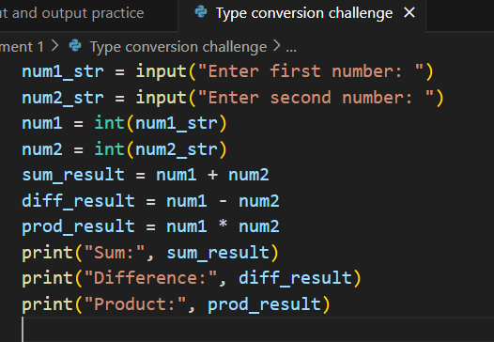

**Output:**

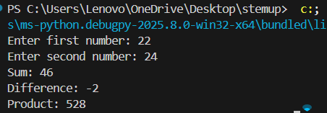

**Test Cases:**

|  |  |  |  |  |
| --- | --- | --- | --- | --- |
| **Input num1** | **Input num2** | **Sum** | **Difference** | **Product** |
| 22 | 24 | 46 | -2 | 528 |
| 7 | 3 | 10 | 4 | 21 |
| 20 | 25 | 45 | -5 | 500 |

**3. Data type classification:**

**Problem statement:** identify the data type of the following inputs in your language of choice:

“123”, 123, 123.45, True, “Hello”

**Algorithm**

1.Define each value one by one

2.Use the built-in type() function in Python to check the data type

3.Print the result

**Code**

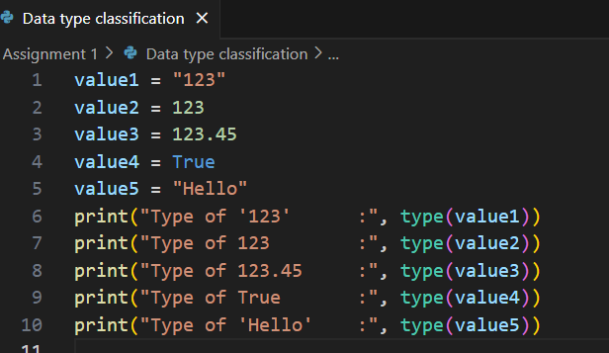

**Output:**

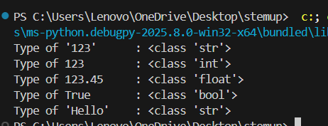

**Test Cases:**

|  |  |
| --- | --- |
| Value | Python Type |
| “123” | str(string) |
| 123 | int(Integer) |
| 123.45 | float(decimal) |
| True | bool(Boolean) |
| “Hello” | str(string) |

**4. Temperature Converter**

**Problem statement:** Write a program that convers Celsius to Fahrenheit using a variable and formula: F = (C * 9/5) + 32

**Algorithm:**

1. Start the program
2. Ask the user to **enter temperature in Celsius**
3. Convert the input to a **float** (decimal number)
4. Apply the formula:  
    Fahrenheit = (Celsius × 9/5) + 32
5. Print the Fahrenheit temperature
6. End the program

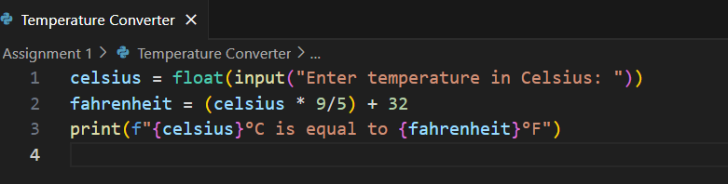**Code:**

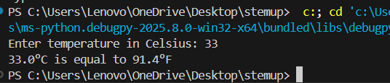**Output:**

**Test Cases:**

|  |  |  |  |
| --- | --- | --- | --- |
| Input Celsius | |  | | --- | |  |   Expected Fahrenheit | Formula Used |
| 33 | 91.4 | (33*9/5)+32 |
| 37 | 98.6 | (37*9/5)+32 |
| 25 | 77.0 | (25*9/5)+32 |

**5. Simple calculator:**

**Problem statement:** create a basic calculator that performs +,-,*,and / between two user provided

numbers

**Algorithm**

1. Start the program
2. Ask the user to enter the **first number**
3. Ask the user to enter the **second number**
4. Ask the user to enter the **operator** (+, -, *, or /)
5. Use if or elif to check which operation to perform
6. Perform the correct operation and display the result
7. End the program

**Code:**

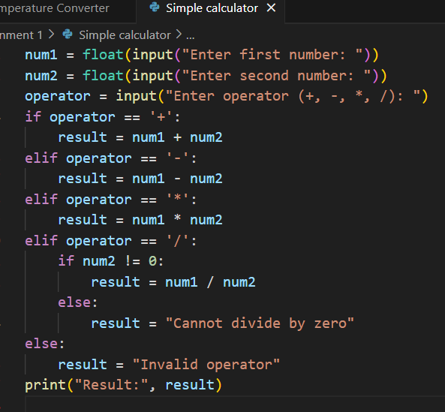

**Output:**

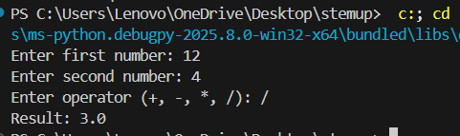

**Test Cases:**

|  |  |  |  |
| --- | --- | --- | --- |
| num1 | num2 | operator | output |
| 12 | 4 | / | 3 |
| 10 | 5 | + | 15 |
| 8 | 3 | - | 5 |
| 4 | 7 | * | 28 |
| 20 | 4 | / | 5.0 |
| 9 | 0 | / | Error: Division by zero |

**SECTION 3: FLOW CONTROL**

**6. Even or odd checker:**

**Problem statement:** accept a number from the user and print whether the number is even or odd

using if else

**Algorithm**

1.Start the program

2.Ask the user to **enter a number**

3.Convert the input to an **integer**

4.Use the **modulus operator %** to check if the number is divisible by 2:

* + If number % 2 == 0, it’s **even**
  + Else, it’s **odd**

5.Print the result

6.End the program

**Code:**

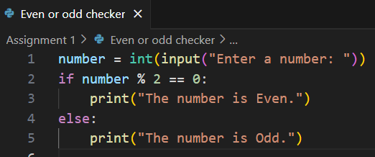

**Output:**

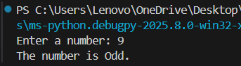

|  |  |
| --- | --- |
| **Input** | Expected Output |
| 9 | 9 is an odd number. |
| 4 | 4 is an even number. |
| 0 | 0 is an even number. |
| -3 | -3 is an odd number. |

**Test Cases:**

**7. Grade calculator**

**Problem statement:** based on marks(0-100), print grade using: A:90+ ,80-89:B, 70-79:C,60-69:D,

60-:E

**Algorithm**

1. Start the program
2. Ask the user to **enter marks**
3. Convert the input to an integer
4. Use **if-elif-else** statements to check the grade range
5. Print the appropriate grade
6. End the program

**Code:**

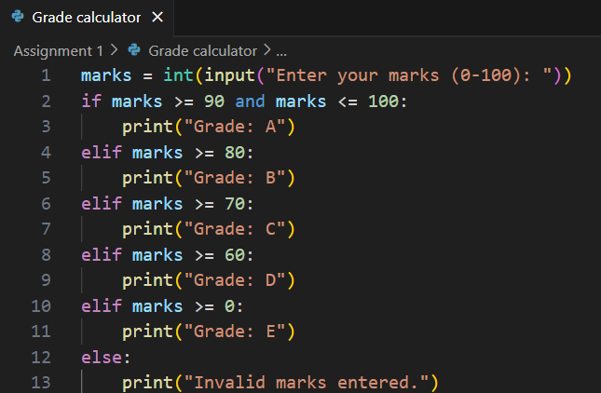

**Output:**

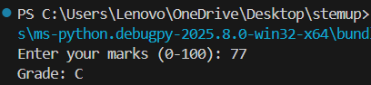

**Test Cases:**

|  |  |
| --- | --- |
| **Input Marks** | Expected Output |
| 77 | Grade: C |
| 95 | Grade: A |
| 65 | Grade: b |

**8. Number comparison**

**Problem statement:** Accept two numbers and print which is greater, or if they are equal

**Algorithm**

1. Start the program
2. Ask the user to **enter the first number**
3. Ask the user to **enter the second number**
4. Convert both inputs to numbers (integers or floats)
5. Use if, elif, else to compare them:
   * If first > second → print first is greater
   * If second > first → print second is greater
   * Else → print both are equal
6. End the program

**Code:**

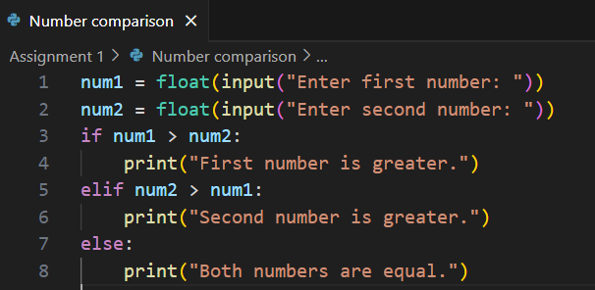

**Output:**

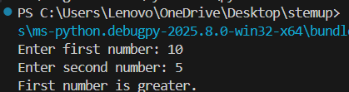

**Test Cases:**

|  |  |  |
| --- | --- | --- |
| num1 | num2 | Output |
| 10 | 5 | 10 is greater than 5 |
| 4 | 8 | 8 is greater than 4 |
| 7 | 7 | Both numbers are equa |

**9. Countdown time**

**Problem statement:** using a while loop, print numbers from 10 down to 1

**Algorithm**

1. Start the program
2. Initialize a variable num = 10
3. Use a while loop to check:
   * While num >= 1, do the following:
     + Print num
     + Decrease num by 1
4. End the loop when num < 1
5. End the program

**Code:**

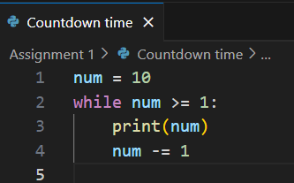

**Output:**

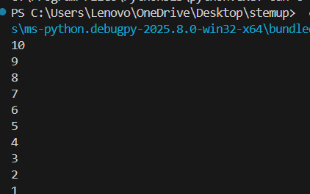

**Test Cases:**

|  |  |
| --- | --- |
| **Initial Value** | Expected Output |
| 10 | 10 9 8 7 6 5 4 3 2 1 |
| 5 | 5 4 3 2 1 |

**10. Multiplication table generator:**

**Problem statement:** Accept a number from the user and print its multiplication table up to 10 using

a for loop

**Algorithm**

1. Start the program
2. Ask the user to **enter a number**
3. Convert the input to an **integer**
4. Use a for loop from 1 to 10
   * In each iteration, multiply the number by the loop counter
   * Print the result in the format: number x i = result
5. End the program

**Code:**

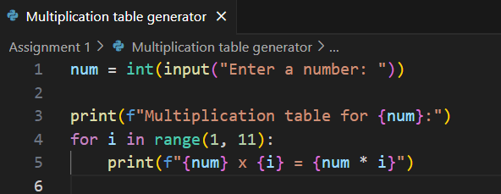

**Output:**

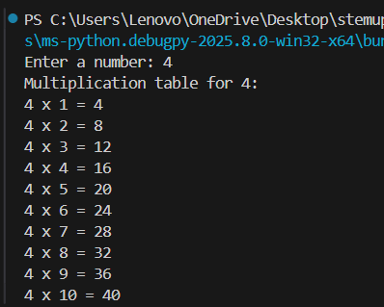

**Test Cases:**

|  |  |
| --- | --- |
| **Input** | **Expected Output (Multiplication Table)** |
| **4** | **4*1=4**  **….**  **4*10=40** |
| **5** | **5*1=5**  **….**  **5*10=50** |